No more experimental animals: more credibility and higher rate of clinical translation in humans promise the new Canadian Center for Alternative Research
by Dr. Maria Iliou, molecular and cellular biologist of cancer.
Positive and promising news from the other side of the Atlanticoceanwere recently released regarding the seek of alternative research methods in biomedicine. A new scientific center under the auspices of the University of Windsor (http://www1.uwindsor.ca/vpri/canadian-centre-for-alternatives-to-animal-methods-0) on the Canadian border, the "Canadian Center for Alternatives to Animal Methods” (CCAAM) in collaboration with its subsidiary lab, the “Canadian Center for the Certification of Alternative Methods” (CCVAM), promise to contribute with their studies to the discovery, certification and promotion of new experimental methods that aim to replace experimental animals in biomedical research, education and chemical toxicology.
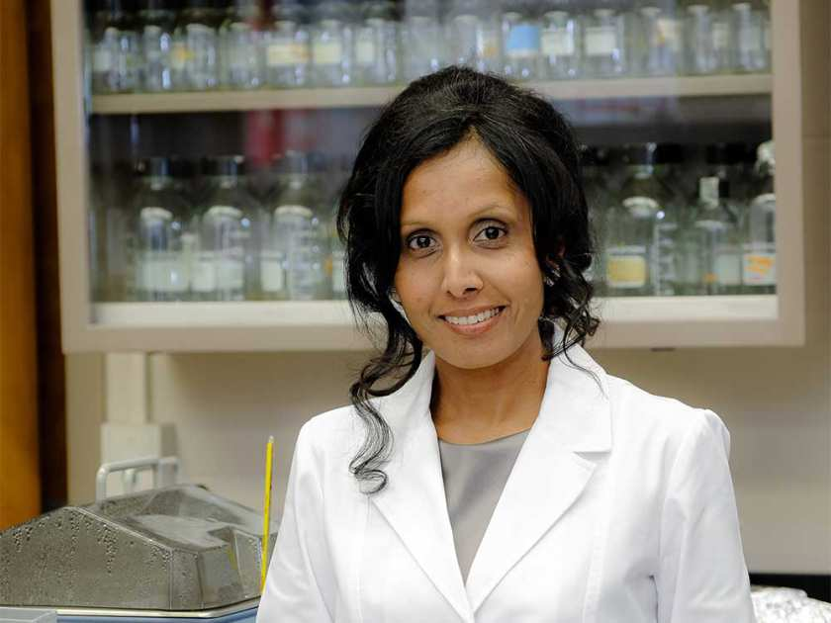
Dr. CharuChandrasekera, founder and director of the New Canadian Center for Alternative Experimental Animal Research Methods at the University of Windsor in Ontario, Canada.
The CCAAM’s Scientific Committee is leaded by the Director of Science of the "Doctors' Committee for Responsible Medicine" (www.PCRM.org) Dr, CharuChandrasekera, a doctor and biologist with bachelor from the University of Michigan Medical School of the USA, with a Mastersdegree in Biochemistry from the McMaster University of Canada and a PhD in Biochemistry and Molecular Biology of Cardiovascular Diseases from the Calgary University, Canada. Dr. CharuChandrasekera continued her career as a postdoctoral researcher at the Michigan Medical School where she studied an experimental gene therapy for cardiomyopathy based on the viral transfer of cardiac troponin C. Subsequently, she moved to the University of Wayne University Medical School in Detroit, USA, where she got engaged in the basic research of various diseases, from cellular signaling incardiomyocytes (receptor-adenosine characterization and their interaction with receptors coupled with G-proteins) to glucose homeostasis and its contribution to reproductive endocrinology (with emphasis on complications in type I and II diabetes).
A successful researcher with a long-term research career and experience in both in vitro and in vivo methodology, she witnessed herself the restrictions imposed by the use of animal models in the study of human disease and decided to join the "Doctors' Committee for Responsible Medicine", contributing to the emergence of a new era in biomedical research, where the hypothesis will be derived from human data, and the experiment will be performed with existing or under development in-vitro, in vivo, ex vivo and in silico "human-based" methods. Why not to seek for new research methods, more reliable and with a higher rate of translation in humans, when according to a recent collaborative study conducted by teams from prestigious Universities such as the Yale and the State University of New York and published in the Journal of the American Medical Association (JAMA), it was found that it is not only the vast majority of prospective medicines that are at an advanced stage of clinical studies that cause very serious and often fatal side effects to patients, but also medicines already approved by the US Food and Drug Administration (FDA) and are already sold to the patients. The study reports that a shocking 32% of drugs approved by the FDA in the 2000-2010 period were associated with a security health incident and needed to either be withdrawn or enter in a "blacklist". Animal models cannot guarantee the safety of new drugs, yet the FDA insists on asking for the use of experimental animals during testing.
The Canadian Center for Alternatives to Experimental Methods at Windsor University plans to launch its first workshop on October 2-3, 2017. We wish every success in this project with the hope that such initiatives will multiply in the future. In closing, we cite part of the interview Dr. Chandrasekera gave to Windsor Star News correspondent Dalson Chen (dchen@postmedia.com) and was posted last June at Windsor Star News from Ontario, Canada.

No more lab rats: Alternatives to animal testing sought at new Windsor research Center
Dalson Chen, Windsor Star News, Ontario, Canada
dchen@postmedia.com
Published on: June 19, 2017 |
White mice and other animal test subjects might be an iconic part of the public’s image of a scientific laboratory — but it’s way past time for that to change, says University of Windsor researcher Dr. CharuChandrasekera.
“Yes, we’ve used animals for decades — It’s not working,” Dr. Chandrasekera said. “When you have 95 per cent failure to translate from animal models to human clinical trials, there’s something wrong with the paradigm.”
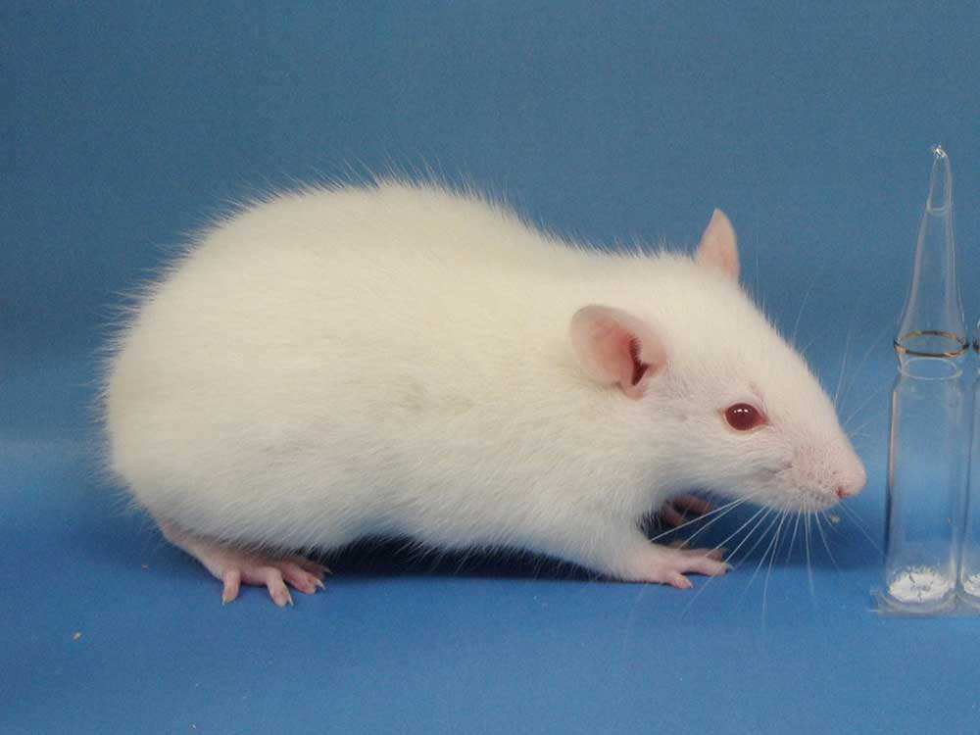

A lab rat at Kyoto University in 2013 (Takehito Kaneko/AFP/GETTY IMAGES)

A biochemist and molecular biologist, 42-year-old Chandrasekera is the founder and director of the university’s new Canadian Centre for Alternatives to Animal Methods. Set to begin its work in earnest in October, the center will put the University of Windsor on the forefront of developing, validating, and promoting biomedical research and education techniques that do not use animals.
The idea behind the center grew in Dr. Chandrasekera over the course of 17 years of experience in biomedical research focused on cardiovascular disease and diabetes. She saw first-hand the low rate of congruence between animal test results and effectiveness on humans. The final straw came for Dr. Chandrasekera after her father suffered a heart attack. She asked a leading professor on certain protein receptors about their usefulness to protect the human heart. She was told there was no information on that: All the studies on those receptors had been done with the hearts of lab mice. “This was a researcher who had worked on this for 20-some years. And he had never bothered to look at it on humans,” Dr. Chandrasekera said incredulously.
“It was the turning point for me. Why continue with this work if I’m not doing it for the benefit of human beings?”
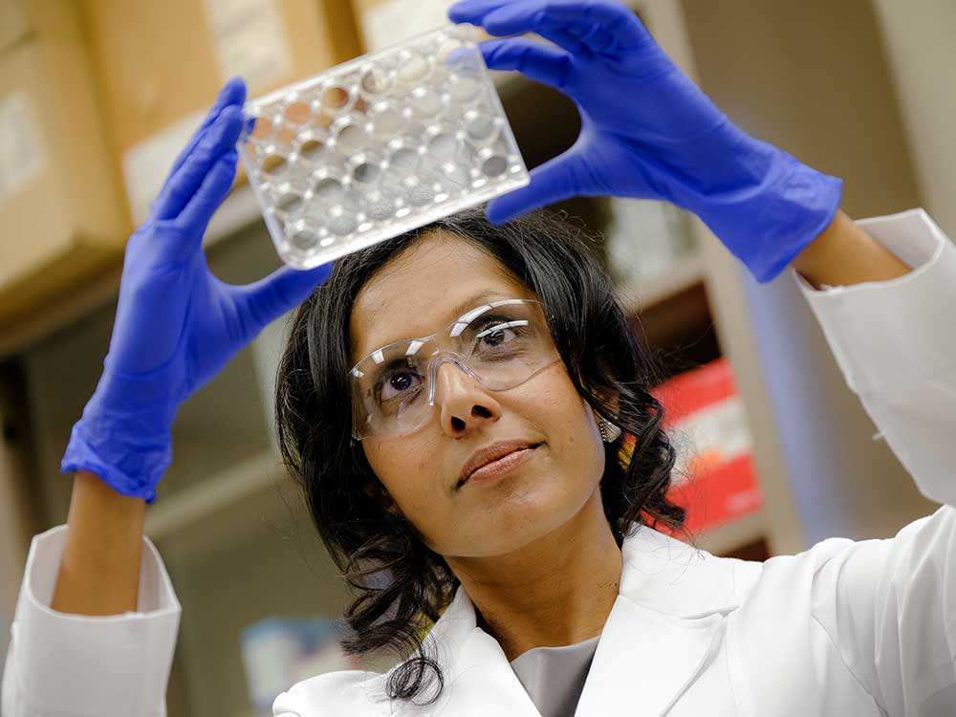

Dr. CharuChandrasekera, founder and director of the New Canadian Center for Alternative Experimental Animal Research Methods at the University of Windsor in Ontario, Canada (courtesy of the University of Windsor).

Current scientific literature — as well as the U.S. Food and Drug Administration — agrees with Dr. Chandrasekera. She noted that the research communities of other countries around the world are already moving away from animal testing.
Canada, however, has lagged behind.
But if everyone realizes that animal testing is almost useless for research purposes, why has it been prevalent for so long?“This is one of those questions. If you look at anything in human history, it’s very difficult to change long-standing paradigms,” Dr. Chandrasekera said. “The right of women to vote. The end of slavery. It’s always going to be a long, hard process.”
Dr. Chandrasekera said animal testing is so embedded in scientific culture that it’s frequently done for the purposes of fulfilling grant applications rather than any inherent research value. “There is a mindset that we need to change.”
And change won’t happen unless there are real alternatives. Dr. Chandrasekera said there have been groundbreaking advances in computer modelling, and work involving human cells and tissues.
One of the areas Dr. Chandrasekera intends to pursue further with the CCAAM is organoid modelling: using adult human stem cells to grow three-dimensional structures and create human organs in vitro.
“New technologies will soon replace the utility of animal models,” Dr. Chandrasekera promised.
The CCAAM’s laboratory is now in the process of being set up. Along with Dr. Chandrasekera, the center’s core team will include a scientific director, Philip Karpowicz, and an academic director, Andrew Hubberstey.
Other University of Windsor faculty members from such diverse fields as biology, biochemistry, philosophy and ethics will also be involved in the center.
Eventually, the center will offer degree programs in animal replacement science.
Education is the key, Dr. Chandrasekera said. “Our current paradigm is being ingrained into students. We want to get them to think outside of that cage. We want to teach them to think beyond animal models.”
The CCAAM plans on launching its first workshop Oct. 2-3.

Sources
https://www.pcrm.org/research/good-science/pcrm-scientist-leads-new-canadian-centre-for-alternatives-to-animal-methods
http://jamanetwork.com/journals/jama/article-abstract/2625319
http://windsorstar.com/g00/news/local-news/no-more-lab-rats-alternatives-to-animal-testing-sought-at-new-windsor-research-centre?i10c.referrer
http://www1.uwindsor.ca/vpri/canadian-centre-for-alternatives-to-animal-methods-0

